Tertiary Entrance Examination, 2008

HUMAN BIOLOGY

Provisional Marking Key

For use by Chief Marker only

This copy of the marking key should be annotated with any changes that have arisen in the marking process, and returned to the Curriculum Council so that a finalised marking key can be printed.

Question | Answer | Question | Answer
1 | A | 21 | D
2 | B | 22 | C
3 | B | 23 | B
4 | A | 24 | D
5 | D | 25 | D
6 | A | 26 | B
7 | B | 27 | A
8 | C | 28 | D
9 | A | 29 | C
10 | B | 30 | C
11 | C | 31 | B
12 | B | 32 | C
13 | D | 33 | A
14 | B | 34 | D
15 | C | 35 | C
16 | A | 36 | B
17 | D | 37 | A
18 | C | 38 | C
19 | A | 39 | A
20 | C | 40 | B

PART II (80 Marks)

Write answers to all questions on the ruled lines after each question or in the spaces provided within each table. Write your answers in blue or black ballpoint or ink pen.

Question 41 (Total 8 marks)

Refer to the following diagram of the ear for this question.

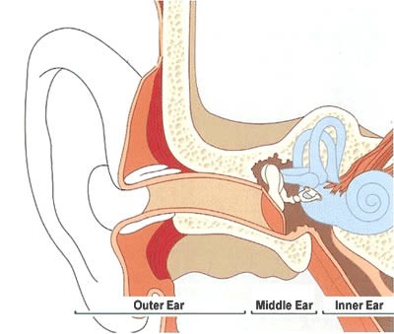
E
D
C
F
A
B

(a) Identify and name the structure in the diagram above that is important in maintaining suitable pressure in the middle ear.
(1 mark)

D: Eustachian tube

(b) Describe the transfer of sound waves from F through to the sound receptors in C.
(3 marks)

- sound waves from F set up vibration in the tympanic membrane (E) (1)
- movement of the auditory ossicles (A) (1)
- vibration of the oval window (1)
- vibration of fluid in the cochlea (C) (1)
- stimulation of the hair cells (sound receptors) in C (1)

(Max of 3 marks)
(c) Explain how structure B allows the person to know how their body is moving.
(2 marks)
- movement of head causes movement of fluid in semi-circular canals. (1)
- movement detected by receptors (1)

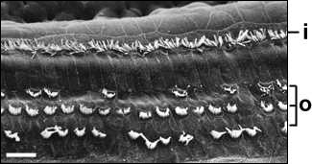
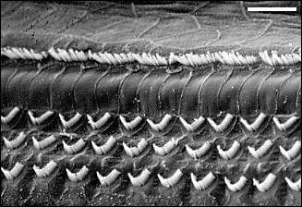
(d) Picture A left shows the damage caused by high doses of a particular antibiotic on the hair cells in the organ of Corti. What hearing defects could be experienced by this person as a result of this treatment with antibiotics?
A. Damaged hair cells in the organ of Corti
B. Normal hair cells in the organ of Corti

- frequency drop out
- blurring of sounds
- lack of audio acuity
- tinnitus - ringing in ears
- hearing loss (only) (1)

Any of the above for 1 mark each

(2 marks)

Question 42 (Total 11 marks)

(a) Alkaptonuria is a condition where urine may turn brown/black on contact with air, especially when left for a period of time. It is a rare condition affecting 1 in 250,000 to 1 million in the population worldwide. It is more common in isolated, mountainous areas of Slovakia in eastern Europe at about 1 in 19,000 in the population.

Explain why the incidence would be higher in a particular area of Slovakia.
(2 marks)

- inbreeding within a small population (1)
- lack of gene flow into/out of the population (1)
- random genetic drift in a small, isolated population (1)
(any 2 for 2 marks)

(b) The pedigree below shows the individuals in a family who show the symptoms of alkaptonuria.

I

II

III

IV
1 2
1 2 3 4 5
1 2 3 4

1

(i) Is this condition controlled by a dominant or recessive allele? Support your answer with evidence from the pedigree above.
(3 marks)

- recessive (1)
- two unaffected parents produce an affected child (1)
- II 4 and II 5 produce III 4 (1) or any other combination shown in the pedigree

(3 marks)

(ii) What is the probability of II 3 carrying an alkaptonuria allele? Show your working.
(3 marks)

- I 1 and I 2 are heterozygous (1) - produced II 2 (1)
I 1

I 2 | A | a
A | AA | Aa
a | Aa | aa | (1)
II 2

- II 3 does not have the condition so is not aa
- 2 of 3; 67%, 2/3 of the non-affected have at least one a allele (1) - must have this point to get 3 marks

(c) Refer to the following pedigree for this question.

1 2
1 2 3 4 5 6
1 2 3 4 5 6 7
I
II
III

Could this family tree show the inheritance pattern for Duchenne muscular dystrophy? Use evidence from the family tree to support your answer.
(3 marks)

- No (1) Duchenne muscular dystrophy is sex-linked, recessive (1)
- boys affected do not usually survive to reproduce - II 2 and II 5 have (1) or
- fathers can’t pass the Duchenne condition onto their sons - II 2 and II 5 have (1)

(3 marks)
Question 43 (Total 4 marks)

Drugs appear to be increasingly available to young adolescents. Before indulging in drug-taking, it would be sensible to think of the biological and social effects of different drugs.

(a) What are two short term biological effects of alcohol use?
(2 marks)

Feelings of relaxation and cheerfulness
Blurred vision
Coordination problems.
Unconsciousness due to depressed activity of the central nervous system
Death (alcohol overdose)
(any 2 for 2 marks)

(b) What are two social effects of long term heroin use?
(2 marks)

Addiction and withdrawal
Drug-related crime & violence
Motor accidents
Death
Transmission of HIV
Loss of productivity etc.
(any 2 for 2 marks)
Question 44 (Total 6 marks)

Refer to the following diagram and graph.

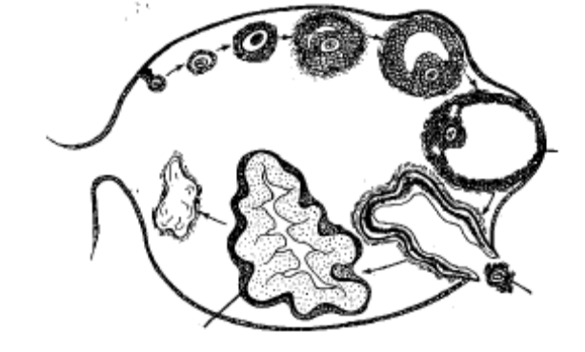
Z
Y
X

(a) Name

(i) which of the above structures becomes a temporary endocrine gland.

X: corpus luteum (1)
(ii) what hormone(s) are produced by the temporary endocrine gland.

Progesterone/Oestrogen
(2 marks)

The graph below shows the daily concentrations of 4 different hormones obtained from a woman. Day 0 refers to the day she started her blood tests.

Hormone concentration in blood
Time in days
Follicle Stimulating Hormone (FSH)
Luteinizing Hormone (LH)
Progesterone
Oestrogen
A
B
C
D
0
2
4
10
8
6
12
14
16
18
20
22
24
26
28
30

(b) Which point on the graph represents the same event indicated by Y on the diagram on
the previous page?
(1 mark)

B (1)

(c) State the relationship between FSH and LH as shown in the graph.
(1 mark)

Parallel changes of blood concentrations of LH and FSH (1) or
Both peak and decline at the same time. (1)

(d) The contraceptive called the ‘mini pill’ contains only the hormone progesterone. Explain how taking this hormone on a daily basis controls fertility.
(2 marks)

Hormone control of:
Stops development of ovarian follicle (1)
Progesterone thickens the cervical mucus and prevents sperm from entering the uterus. (1)
Prevent implantation of fertilised egg through changes to the endometrium (1)

(any 2 for 2 marks)

Question 45 (Total 10 marks)

Student researchers wanted to observe and record changes in urine volumes in response to drinking different solutions. One person volunteered to drink one litre (1 L) of distilled water which contained no salts. Another person volunteered to drink a saline solution that had the same salt concentration as the body fluids (0.96% salt). Urine volumes were collected every 30 minutes for both the volunteers, starting 30 minutes before they drank the solutions.

Time (minutes) | Urine Volumes  (mL)
 | Person 1  0% salt solution | Person 2  0.96% salt solution
-30 | 55 | 50
0 | 40 | 35
30 | 345 | 55
60 | 410 | 90
90 | 205 | 45
120 | 60 | 95
150 | 85 | 105
180 | 60 | 95
210 | 45 | 55
240 | 55 | 45

(a) Graph these results on the grid provided. (5 marks)

title - includes both axes labels
labels for axes
units for axes
proper number line spaces on axes
key to graph lines
points plotted correctly

deduct 1 mark for each incorrect point up to a maximum of 5.

(b) Why were recordings made prior to Person 1 and Person 2 drinking the solutions?
(2 marks)

To provide the control value of normal urine production (1)
For comparison of volumes after drinking (1)

(c) State one factor that is changed in the internal environment as a result of drinking 1 L of 0% salt solution.
(1 mark)

Blood volume (1)
Osmolarity (concentration) of the blood fluids (1)

(d) At what time would the blood concentration of ADH be the lowest for Person 1? Explain your answer.
(2 marks)

Between 30-60 minutes because urine volume is greatest at 60 minutes (1)
ADH causes urine retention. Low or no ADH = high urine production (1)
Question 46 (Total 8 marks)

Refer to the following diagrams showing the parts of a neurone and some components of a reflex arc.
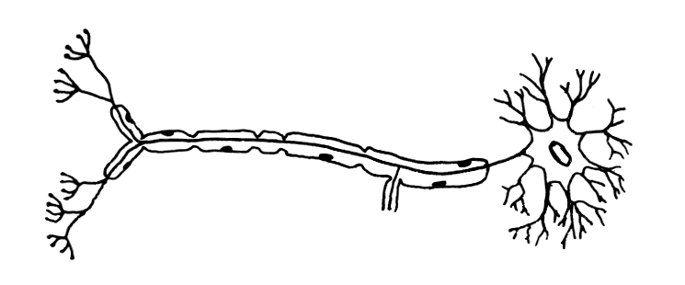
A
B

(a) Identify the following structures in the diagram of the neurone above.
(2 marks)
A: axon (1)

B: dendrite (1)

(b) Which neurone in the reflex arc in the diagram below is of the type shown above?
(1 mark)

Neurone X (1)

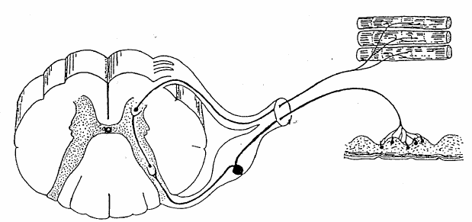
Muscle
Neurone X
Spinal cord
Synapse A
Synapse B
Skin
Neurone Y

(c) (i) The blue-ringed octopus, which is common on shallow inshore reefs along the coastal beaches and offshore islands of south-west Western Australia, produces a toxin that blocks nerve transmission at some synapses. A person who was revived after being stung by a blue-ringed octopus said he was consciously aware of all efforts of the rescuers when they were doing CPR, but that he could not respond to any of their questions.

Which synapse, A or B, shown in the diagram of a reflex arc would be blocked by the toxin? Explain your answer.
(3 marks)

Synapse A: (1)
- talking requires muscle movement (1) or
- impulses to muscles are blocked at A (1)
- The sensory pathway through B is okay as he is aware of what the rescuer were doing (1) must have this point
(3 marks)

(d) In Hansen’s disease (leprosy) nerve endings in the skin degenerate. Sufferers of Hansen’s disease often don’t realise they have been cut or burned. Explain why.
(2 marks)

- Receptor needs to be stimulated to produce a nerve impulse. (1)
- The nerve impulse is either not formed or not transmitted. (1)

(2 marks)

Question 47 (Total 8 marks)

A study of human populations indigenous to areas prior to European exploration in the 15th Century shows particular trends in height/weight ratios and skin colours.

Change in height/weight ratio with distance from the equator
high

Height/weight
ratio

low
AB
Increasing distance from the equator
Equator
•

(a) What is the most likely body shape (somatotype) of a person living at location A?
(1 mark)
ectomorphic (1)

(b) What is an advantage of having a low height/weight ratio when living at B?
(1 mark)
reduce heat loss (1)

Skin colour shows a similar trend with geographical distribution.

Change in skin colour with distance from the equator
AB
Increasing distance from the equator
dark

Skin
colour

light
Equator
•

(c) What is the advantage of the skin colour for people living at A?
(1 marks)
reduces risk of skin damage (1) and sunburn (1) or skin cancer (1)

(d) A lack of vitamin D is common among people originally from locations such as A who move to locations such as B. Why does this happen?
(2 marks)
UV is required to make Vitamin D in the skin (1). Dark skin reduces the penetration of UV into the cells to produce vitamin D (1)

(e) Colonisation of equatorial areas by Europeans occurred after the 15th Century. Most of the local indigenous populations decreased dramatically during the first few years of contact with the European settlers.

Give one possible reason for the decline of local populations.
(1 mark)
disease introduced for which the local population has no immunity (1)

(f) After colonisation, the indigenous population of countries such as Australia, gradually lost its nomadic lifestyle.

Suggest two reasons why this occurred.
(2 marks)
disruption of populations by disease (1)
alternative use of traditional lands for agriculture (1) urban development (1)

Question 48 (Total 9 marks)

Refer to the following diagram showing the location of major endocrine organs of the body for this question.

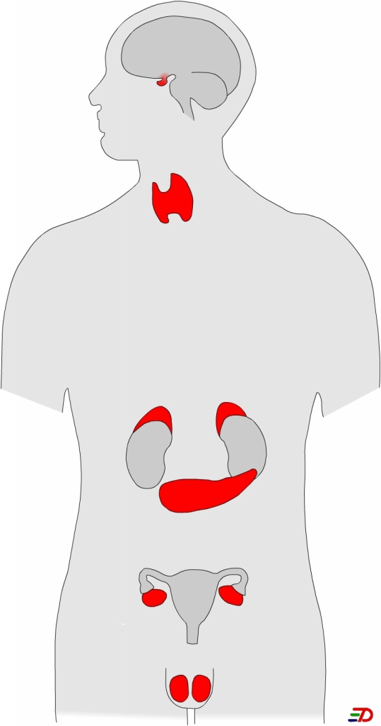
F
B
C
E
D
A

(a) Identify the following endocrine glands in the diagram above.
(2 marks)
B: thyroid gland (1)

F: pancreas/islets of Langerhans (1)

(b) Adrenal glands (C) have two distinct parts. State one hormone produced by each part.
(2 marks)

 | Adrenal medulla | Adrenal cortex
Hormone produced | Epinephrine (mostly)  Norepinephrine (1) | Cortisol  Aldosterone  Androgens (1)

(c) Name one hormone produced by the anterior pituitary that influences the fertility of males and females.
(1 mark)

Gonadotrophins or LH or FSH

(d) State two ways in which hormones affect target cells.
(2 marks)

- changes cell membrane permeability
- activates specific genes (changing the rate of transcription)
- changes the rate of enzymatic activity (hence metabolic activity in the cell)
- promotes protein synthesis
1 mark per correct point

(e) Some athletes take anabolic steroids, such as testosterone, to improve their performance. This practice has been banned by the International Olympic Committee.
What are two changes to the body that occur as a result of taking steroids?
(2 marks)

- liver damage
- shrinking of the testes
- eventual sterility
- increased protein synthesis and muscle growth
- increases libido (sexual drive)
1 mark per correct point

(any 2 for 2 marks)

Question 49 (Total 8 marks)

The following phylogenetic trees portray the relationships between different evolutionary groups suggested by two different anthropologists.

H. sapiens
A. afarensis
H. erectus
H. erectus
H. ergaster
H. habilis
H. habilis
A. robustus
A. robustus
A. boisei
A. boisei
A. aethiopicus
A. africanus
A. africanus
A. afarensis
H. sapiens
Johanson-White model
Wood
model

(a) According to the two models, how many fossil species existed 2 million years ago?
(1 mark)

Three

(b) For these two models, what is the difference in the importance of A. africanus in the evolution of modern humans?
(2 marks)

J-W model - dead end; no influence on development of Homo
Wood model - main line from which Homo developed
(c) H. erectus is shown as a direct ancestor of H. sapiens in the Johanson-White model, but not the Wood model. What fossil evidence would support the Wood model?
(2 marks)

Fossils found at the same geological time (1) and place (1)

(d) Both models have the Australopithecus and Homo groups present at the same geological time. What three features of the fossils would distinguish them as Australopithecus or Homo?
(3 marks)

Feature | Hominids | Australopithecus
Foramen Magnum | Central foramen magnum positioned beneath the skull | Post-central foramen magnum
Face | Flattened face/ reduced prognathism/ reduced jaw | Prognathic face/ enlarged jaw
Spine | S-shaped spinal curve/ cervical/ lumbar curvatures | C-shaped spinal curve  No cervical/ no lumbar curvatures
Pelvis | Wide short pelvis/ bowl-shaped | Narrow pelvis/ not bowl-shaped
Foot Arches | Transverse and longitudinal foot arches | No transverse foot arch

Question 50 (Total 8 marks)

The drawings below show different sets of tools found at different archaeological sites associated with different human evolutionary groups.
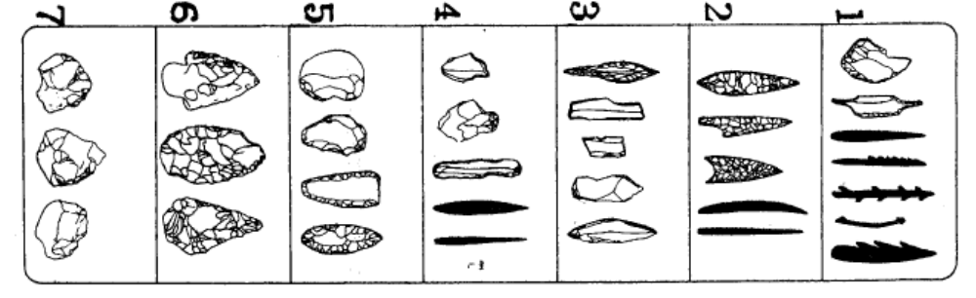
Set 1Set 2Set 3Set 4Set 5Set 6Set 7

(a) Which set of tools would be the oldest? Explain your choice.
(2 marks)

Set 1 (1)
- all of a similar shape indicating no specialisation (1)
- not much working of the surface - all have unworked sections (1)
- working is coarse (1)

(b) What does Set 4 indicate about the uses of different tools?
(2 marks)

- greater specialisation of tool types (1)
- each tool had a particular purpose (1)
- tools were used for more tasks (1)

(c) What trends in tool development are shown from Set 2 to Set 6?

- finer workmanship
- Variety of materials
- cores and flakes used
(any 2 for 2 marks)

(d) What dating method could be used directly on some tools in Set 7 but not in Set 1? Explain your answer.
(2 marks)

Set 7: carbon dating (1)
has tools make from bone which contain carbon (1)
Set 2 has only stone tools (1); too old for carbon dating (1)

Part III (40 Marks)

Answer one question from Section A and one question from Section B. Illustrate your answers with diagrams where appropriate. Up to two marks may be deducted for poorly structured answers: that is, answers in point form or diagrams not explained in the text of your answers. Do not write answers in pencil. Write your answers on the lined pages in your Question/Answer Booklet following the end of the questions.

Section A

Question 51 (Total 20 marks)

(a) Describe four mechanisms of transmission of infectious diseases caused by bacteria. Give an example of a bacterial infection for each mechanisms described.
(8 marks)

- water - typhoid/cholera (1)
  - human wastes from infected person containing bacteria contaminates drinking water
  - bacteria is spread by drinking contaminated water (1)

- air - pneumonia (1)
  - coughing or sneezing by an infected person sprays droplets containing bacteria into the air
  - people nearby can inhale droplets/bacteria (1)

- contaminated food - salmonella food poisoning (1)
  - bacteria breed in food
  - if not cooked or stored properly bacteria transfer to consumer (1)

- vectors - bubonic plague (fleas/rats) (1)
  - transfer of bacteria between organisms by an intermediate organism
  - vector bites infected person and transfers bacteria to the next one it bites (1)

- direct contact - gonorrhoea, syphilis (1)
  - an infected person touches or exchanges body fluids containing bacteria to another person. (1)

- skin penetration - clostridium or tetanus (1)
  - bacteria enter the body when an object carrying bacteria breaks the skin (1)

Description 1 mark
Example 1 mark must be bacterial examples

(b) Explain four (4) of the body’s external defences against infection by bacteria.
(4 marks)
- acid secretions - urine, vagina, stomach
  - reduce activity of bacteria because pH is outside bacterial tolerance limits. (1)

- enzymes - in tears and saliva
  - break down (digest) cellular structures destroying bacteria (1)

- antiseptics - in sebum - skin
  - stop the functioning of bacteria or kill bacteria (1)

- mucus covering of membranes - trachea, bronchi
  - traps and immobilises bacteria (1)

- hair and cilia - respiratory system
  - filter and trap bacteria before reaching the lungs (1)

- skin
  - impermeable barrier to bacteria (1)

State 4 with no explanation - max 2 marks

(c) Explain the response of the immune system to a bacterial infection.
(8 marks)

Antibody mediated response

- recognition of antigen by B-cells
- B-cells activates to enlarge and divide to form a clone of plasma cells and some memory cells
- plasma cells produce antibodies
- antibodies released into blood stream
- antibodies and antigen combine to form antigen-antibody complex

(4 points at 1 each)

Cell mediated response

- recognition of antigen by T-cells
- T-cells activated and sensitised
- T-cells clone to form killer T-cells and memory cells
- killer T-cells migrate to site of infection
  - destroy antigen on contact
  - attract macrophages to engulf antigens and anti-antibody complex

(4 points at 1 each)

or

Question 52 (Total 20 marks)

(a) Explain the functions of each component of the steady-state control system in maintaining the internal environment within narrow tolerance limits.
(8 marks)
Correct sequence needed to gain full marks
- Stimulus - any factor that is recognised as being beyond the tolerance limits
- Receptor - part of the body recognises the factors is beyond the tolerance limits (3)

- Modulator - relay and integration of information from the receptor to appropriate effector (2)

- Effector - organ that produces the response)
- Response - change that occurs to counteract the stimulus (3)

- Feedback - effect on the original stimulus to bring it back to within the tolerance limits (2)

(b) Explain how different body systems work together to maintain the temperature of the internal environment within particular tolerance limits.
(12 marks)

In the body, heat is produced by:
- muscular activity, at least one from here
- assimilation of food; and,
- processes that contribute to the basic metabolic rate.

(2 at 1 mark each)

Heat is lost from the body by:
- radiation;
- conduction; at least one from here
- convection; and,
- evaporation of water in respiratory passages and on the skin.

(2 at 1 mark each)

Temperature regulation is controlled by the hypothalamus. Information from the temperature-sensitive cells in the anterior hypothalamus is compared with the hypothalamic set point (normally 37EC) and the appropriate response is instituted.

- If the temperature registered is greater than 37EC, sweating and cutaneous vasodilation are activated.
- If the temperature is less than the set point, cutaneous vasoconstriction, shivering, and increased secretion of catecholamines are instituted.

(8 marks)

Flow Chart: ‘Maintenance of body temperature’

Vasodilation in skin,
heat loss by conduction

Hypothalamus

Thermoreceptors

Sweating & evaporation
Tendency for body temperature to fall
Constant body temperature
Tendency for body temperature to rise
Decrease in sweating

Hypothalamus
Vasoconstriction in skin, shivering and increased metabolism

Thermoreceptors
Fall in body temperature
Rise in body temperature

(8 marks)

Section B

Question 53 (Total 20 marks)

(a) Explain why evidence of the existence of some organisms is found in the fossil record but there is no evidence of others.
(6 marks)

Conditions of fossilization
- need to be protected from decay by micro-organisms
  - covered
  - lack of oxygen
- need to be left undisturbed while sediments for rock
- organisms not in an environment that supplies these conditions
(2 marks)

Structure of organisms
- most fossils formed from solid body parts such as bones and teeth
  - many organisms do not have hard structures
- soft body parts can leave impressions
  - impressions may be too shallow to be preserved during rock formation
(2 marks)

Geological disturbance
- earth movements and erosion can destroy fossil remains
(1 mark)

Fossil hunting
- fossils may not be recognised
- may not be looking in the right place
- layers of rock containing fossils may not be exposed at the surface - difficult to find deeply buried fossils
(2 marks)

(b) Describe and explain two (2) techniques of relative dating used to analyse fossil finds. Outline the limitations of these techniques.
(8 marks)

Technique | Describe | Explain | Limitations
stratigraphy  (1) | position of fossil in layers of sedimentary rock  (1) | Layers of sedimentary rock at the top are younger than those at the bottom. (1)  The further down the strata the fossil is found, the older it is. (1) | - disturbances to the layers of sediments caused by earth movements - folding and faulting (1)  - remains may have been buried or fossilised in caves placing them in layers older than when they existed (1)
fluorine dating  (1) | measure of amount of fluorine in fossils compared with others from same site  (1) | Bones left in soils will have ions replaced with fluoride ions. (1)  Older fossils at the site will contain more fluorine than younger fossils. (1) | - can only compare fossils from the same site/location (1)  - fluorine in fossils depends on the amount of fluorine in the surrounding soil and this could change over the site and over time at the same site (1)

(c) Researchers differ in their interpretation of fossil finds. Explain the factors that influence their interpretation.
(6 marks)
- definition of characteristics
- range of measurements for different categories
- priority of characteristics in classification
- condition of the fossil being classified
- parts of the organisms found
- extrapolations based on assumptions
(6 at 1 mark each)

Question 54 (Total 20 marks)

(a) The profiles below indicate the age structure of two different populations. Use profiles A and B to explain the factors that influence demographic transition.
(8 marks)
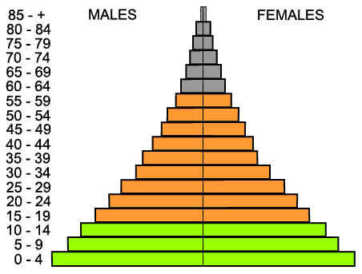
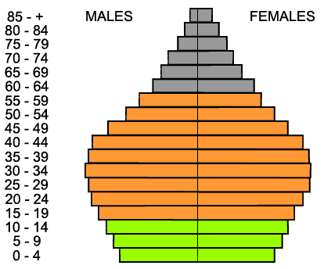
A B

- demographic transition is the process of change to an industrialised country (1) MUST HAVE THIS
- death rates decline (1) - better health care, hygiene and nutrition (1) ; profile B does not taper to a sharp peak as it does in profile A (1)
- birth rates initially remain high (1) - a surge in number of young adults of breeding age (1) - bulge in middle of profile B (1)
- birth rates decrease over time (1) - social changes cause birth rates to decline (1); higher survival rate of children reduce overall size of families (1); narrower base to profile B than profile A
- population stabilises (1); sides of the profile in B almost vertical until the top (1) (around the age of the average life expectancy)
(8 at 1 mark each)

- food supply
- water availability
- medical support
- control of disease
- education
- rate of development of industries
List only max 2 marks

(b) Explain the impact of increasing human population on two (2) of the following:

- global warming
- global energy availability
- water supply and quality
(12 marks)

Impact must relate to increasing human populations

Global warming
- caused by an increase in the amount of carbon dioxide and methane in the atmosphere (1)
- increase in population leads to industrialisation
- increased use of fossil fuels for transport, generation of power
- burning fossil fuels releases carbon dioxide
- increased population increases deforestation of land for agriculture and urban development
- deforestation reduces the amount of carbon dioxide removed from atmosphere
- burning of timber increases carbon dioxide released into the atmosphere
- intensive agriculture increases methane levels in atmosphere
- use of CFC’s also increases greenhouse effect
(6 at 1 mark each)

Global energy availability
- most energy being derived from non-renewable sources (1) coal, oil, gas, nuclear fuels (1)
- diminishing supplies (1) due to increased usage (1)
- increased population all requiring energy (1)
- increase movement of population from rural to urban areas (1)
- urban dwellers use more energy per person than rural dwellers (1)
- increased industrialisation increase energy demand (1) on diminishing supplies (1)
- unequal distribution of energy reserves (1)
(6 at 1 mark each)

Water supply and quality
- good quality water for drinking and agriculture is in short supply (1)
- increasing populations requiring larger amounts of water (1)
- water is used for household purposes (1) and industrial purposes (1)
- increased demand leads to
  - damming of rivers (1) → environmental changes especially to lakes and wetlands down stream (1), reduced amount and quality of water for other purposes down stream (1)
  - pumping of ground water (1) causing land subsidence (1) lowering of the water table (1) drying up of wetlands (1)
- water is used to for waste removal in urban areas (1) → increased nutrients in water ways (1) reducing quality for local ecosystem and use further down stream (1)
- increased industrialisation requires more water - can’t use sea water because of problems of corrosion from salt (1)
- water used for waste removal from industry (1) carrying wastes such as heavy metals, toxic chemicals, fertilisers, detergents pesticides (1) all of which impact on human health - give example (1)
- waste heat from industry (1) causes environmental changes such as fish kills (1)
- explanation of eutrophication
- pesticides/bioaccumulation
(6 at 1 mark each)

